CS 519 Cloud Computing Overview

**VL01: AWS Pricing Calculator**

School of Technology and Computing

### **Scenario 1: Web Application / Amazon Hosted RDS database/ US WEST Region**

|  |  |
| --- | --- |
| **Service** | **Data Required** |
| **Amazon Elastic Compute Cloud (Amazon EC2)** | * Two Linux t3.2xlarge instances * 20 hours per day usage * 1-Year Reserved billing with no upfront costs |
| **Amazon Simple Storage Service (Amazon S3)** | * 100 GB Standard storage * 10,000 PUT, COPY, POST, or LIST requests * 5,000 GET, SELECT, and other requests. * 1 GB data returned by S3 Select * 10 GB data scanned by S3 Select * Amazon S3 data is replicated to US East (Ohio) to S3 Standard storage. |
| **Elastic Load Balancing** | * Three Application Load Balancers * Average of 50 connections/second per Application Load Balancer. * Average connection time is 60 seconds * Average of 100 requests per second for each Application Load Balancer * Data processed per Application Load Balancer for EC2 instances with IP address as targets is 100 GB/month * Average number of rule evaluations per request is 10 |
| **Amazon Route 53** | * Five hosted zones, not using traffic flow * 10 million standard queries per month * 10,000 basic Domain Name System (DNS) health checks per month within AWS * 20,000 basic DNS health checks per month outside of AWS * 10 elastic network interfaces * Average of 2 million resolver queries per month |
| **Amazon Relational Database Service (Amazon RDS)** | * Two RDS db.r3.8xlage standard instances that run MySQL * 100 GB of General Purpose storage and no Provisioned IOPS * 30 GB of data transferred out per month and 5 GB of data transferred in |
| **AWS Support** | * Business Support |

### **Scenario 2: Data Streaming analysis / Data warehousing / Asia Pacific Region (Tokyo)**

|  |  |
| --- | --- |
| **Service** | **Data Required** |
| **Amazon Simple Storage Service (Amazon S3)** | * 50 GB Standard storage * 10,000 PUT, COPY, POST, or LIST requests * 10,000 GET, SELECT, and other requests * 100 GB S3 Intelligent-Tiering Storage (S3 Intelligent-Tiering) * 50 percent of storage is not accessed in a 30-day period * 10,000 PUT, COPY, POST, or LIST requests * 50,000 GET, SELECT, and other requests from the data stored with S3 Intelligent-Tiering * 1,000 requests per month for Lifecycle Transitions from S3 Standard into S3 Intelligent-Tiering- |
| **Amazon Redshift** | * One ds1.xlarge – 2TB-HDD master node with 1-Year No Upfront billing * Two ds1.xlarge – 2TB HDD worker nodes with 1-Year No Upfront billing. * 50 GB data scanned by Amazon Redshift Spectrum |
| **Amazon Kinesis Data Streams** | * 100 PUT records per second * Estimated record size is 500 KB * Three consumers of the data |
| **AWS Support** | * Developer Support |

### **Scenario 3: Queue based application / Analysis using Amazon Athena / Europe (Ireland) Region**

|  |  |
| --- | --- |
| **Service** | **Data Required** |
| **Amazon Virtual Private** **Cloud (Amazon VPC)** | * 100 virtual private network (VPN) connections with 50 percent utilization per month * 1 network address translation (NAT) Gateway with 50 percent utilization per month processing 100 GB per month * 100 GB transferred out per month * 10 GB transferred in per month |
| **Amazon SQS** | * 100,000 requests per month in a standard queue * 10,000 requests per month in a FIFP queue * 50,000 GB per month data transferred out * 20,000 GB per month data transferred in |
| **Amazon DynamoDB** | * 1 TB dataset   On-demand capacity   * 5-KB item size * Eventually consistent reads * 4 million items read per month * 2 million transactional items read per month * 2 million items written per month * 1 million transactional items written per month * 1 million replicated writer per month using on-demand global tables * 100 GB of on-demand data backup |
| **Amazon Elastic File** **System (Amazon EFS)** | * 100 GB of data stored in standard storage * 50 GB stored in infrequently accessed storage * 10 MBps of provisioned throughput |
| **AWS Support** | * Enterprise Support |

**Where do I access the AWS Pricing Calculator?**

[https://calculator.aws/ (Links to an external site.)](https://calculator.aws/)

**Once you have completed your analysis using the AWS Pricing Calculator use the associated discussion thread to summarize your solution and describe why some of the parameters required by the calculator are important and evaluate your solution.**

**Scenario 1:**

In scenario 1, the cost estimations are done for a Web Application hosted in Amazon RDS database in US WEST Region. The cost is based on multiple factors such as number of instances required for the application, usage hours of the EC2 instance and amount of data storage. The region,

which is the physical location around the world where AWS clusters data centers are available, plays an important role is cost estimation. The price varies in accordance with the selected region. The screenshot for the cost estimation based on scenario 1 are as follows: -

**1.EC2 Cost Estimation:**

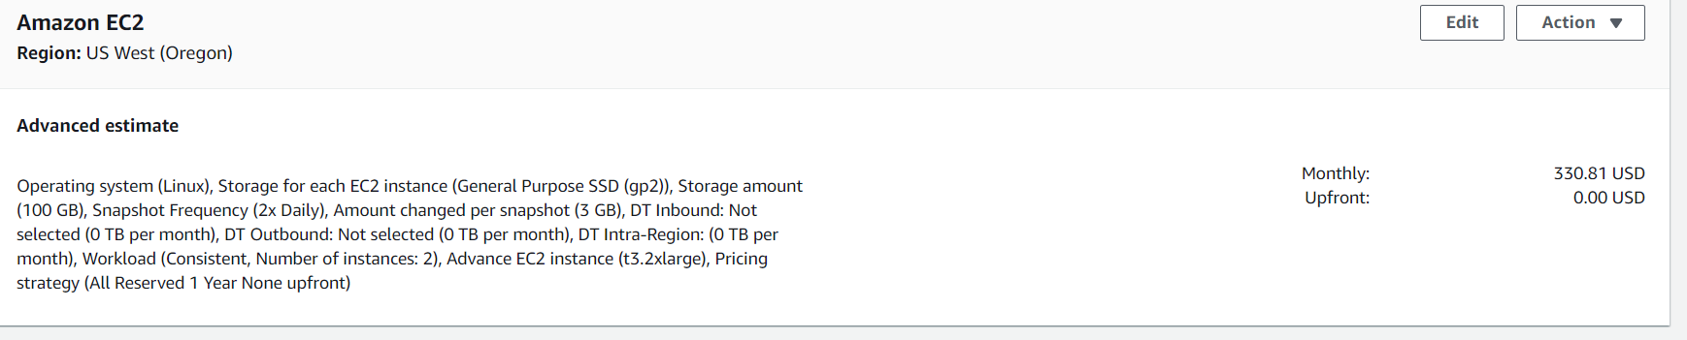

**2.S3**

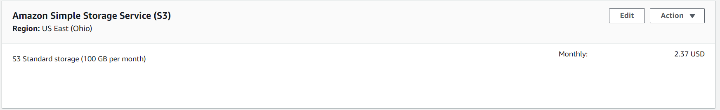

**3.ELB**

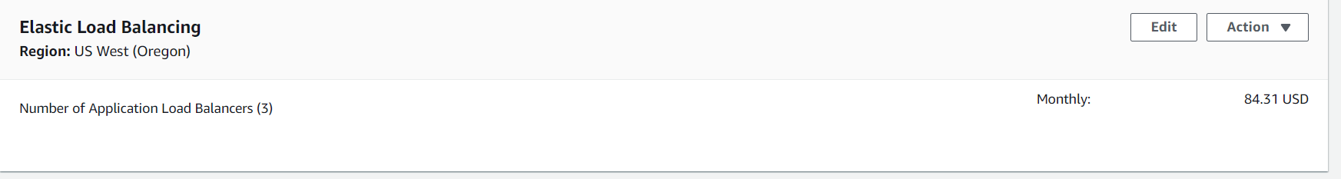  
**4.Amazon Route 53**

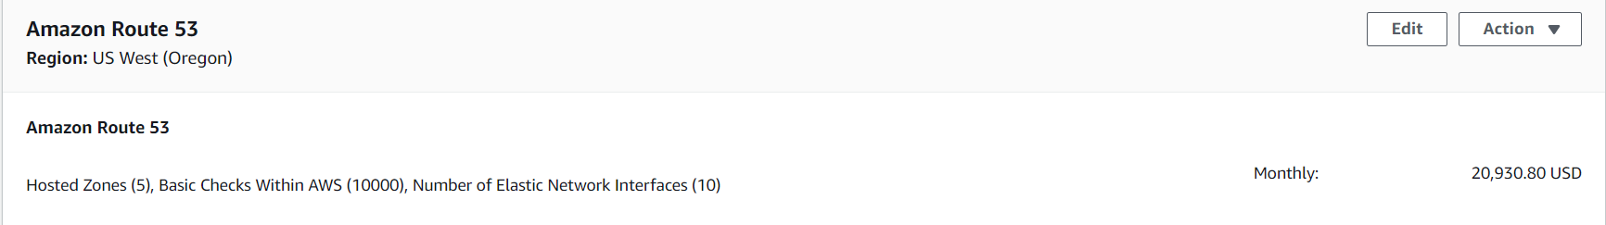

**5.MySql**

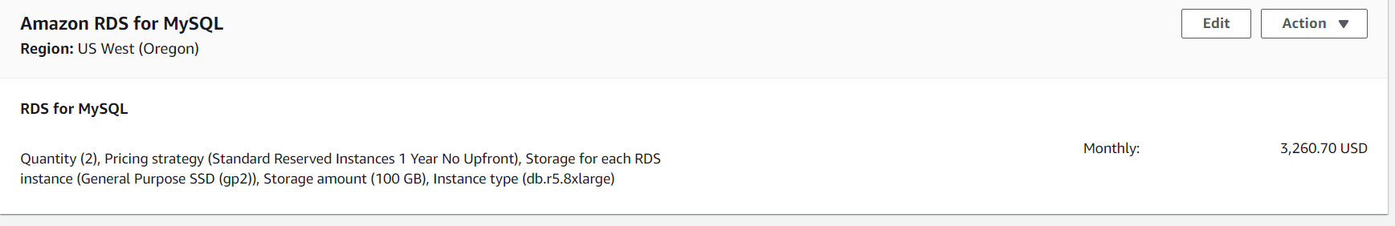

**6.Business Support estimate**

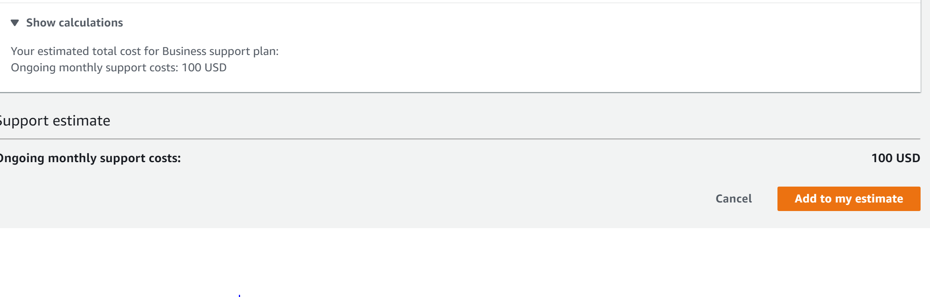

**Scenerio2:**

This scenario deals with estimating the cost for a Data Streaming analysis and Data warehousing for Asia Pacific Region (Tokyo). The cost for Amazon S3 Storage service depends on Standard storage capacity as well as on S3 Intelligent-Tiering. This is the first cloud object storage class that delivers automatic cost savings by moving data between two access tiers — frequent access and infrequent access. The cost also relies on the number of GET, PUT, POST requests to the server. Another important factor that impacts the cost estimation for this scenario is the number of master and worker nodes for Redshift. which is a fully managed petabyte-scale cloud-based data warehouse product designed for large scale data set storage and analysis. The screenshots for estimations are as follows: -

**1.S3**

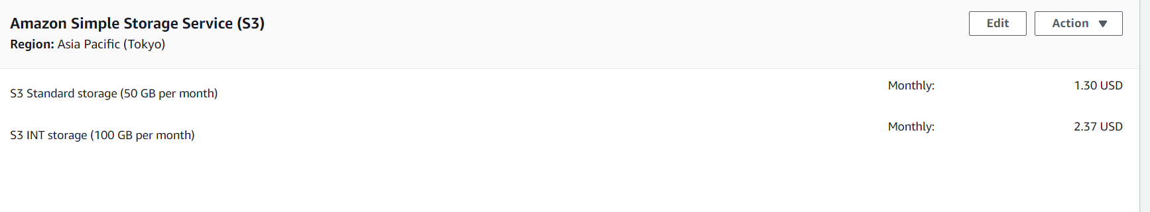

**2.Amazon Redshift:**

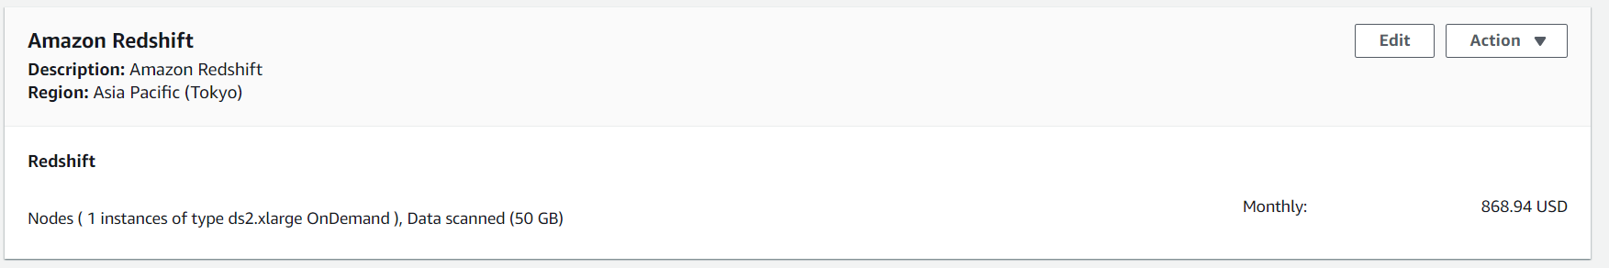

**3.Kinesis Data Streams**

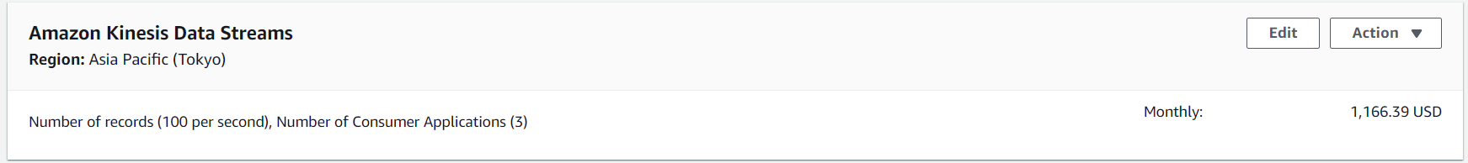

**4. Developer support estimate**

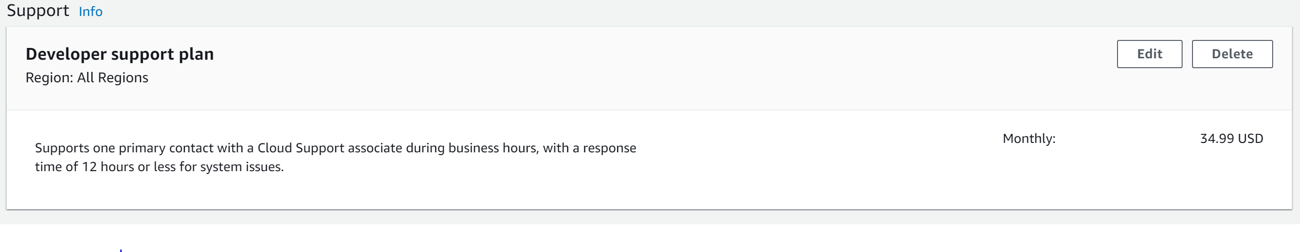

**Scenerio3:**

In this scenario, the cost estimate is for a Queue based application and an analysis using Amazon Athena in Europe (Ireland) Region. The cost estimation is based on various factors. The cost is based on number of VPN connections and the usage hours. The amount of data transferred in and out of the region impacts the cost and estimate. The scenario also uses a dynamo DB. The cost of monthly read and write and storage amount impacts the cost estimation for dynamo DB usage. The type of support also, impacts the cost estimation. The screenshots for cost estimation on Scenario 3 are as follows: -

**1.VPN**

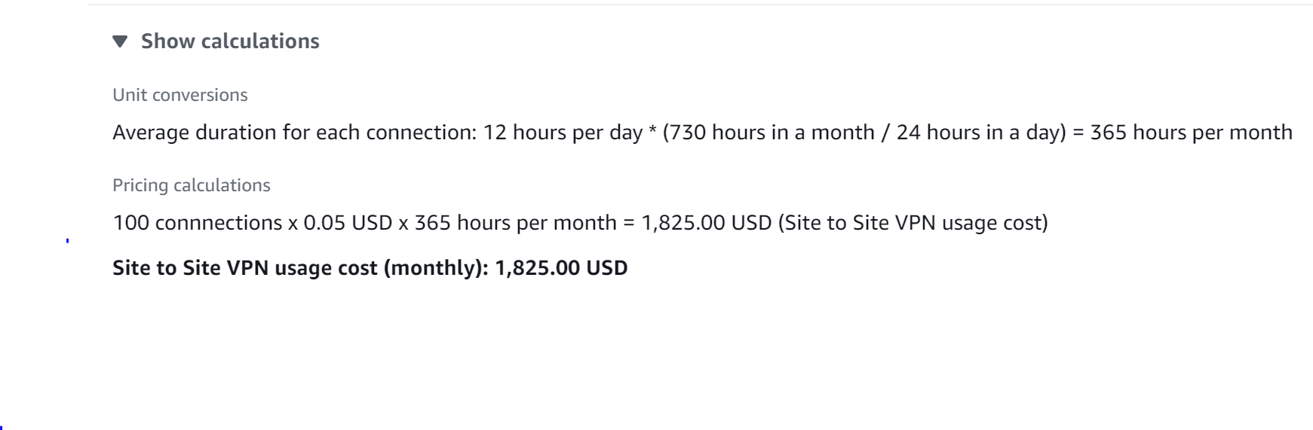

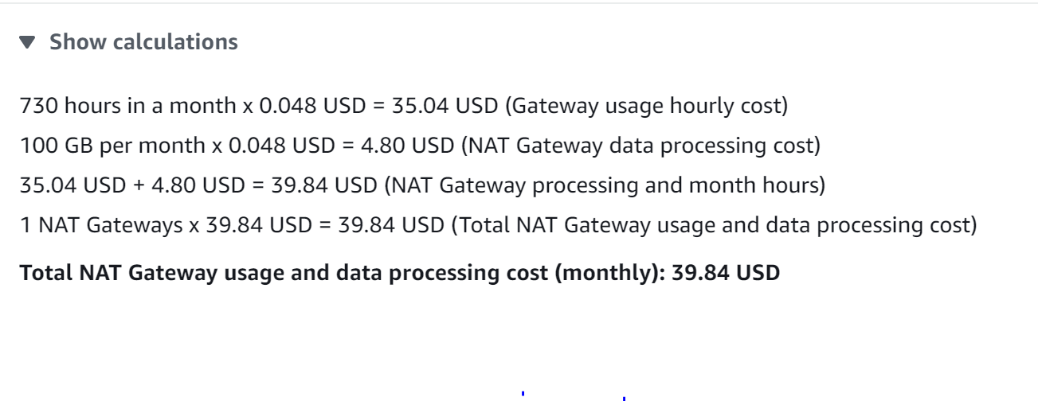





**2.SQS**

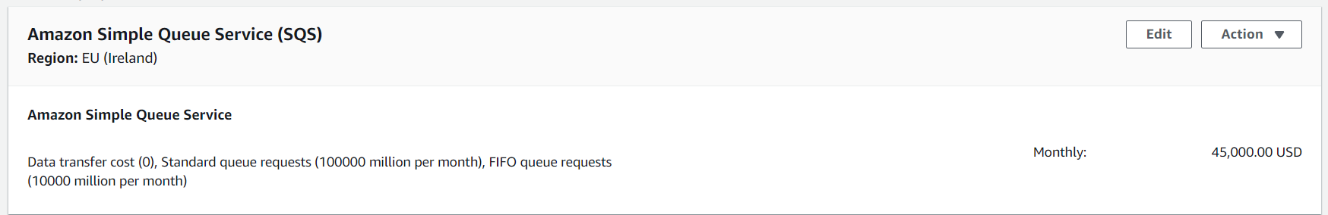

**3.DynamoDB**

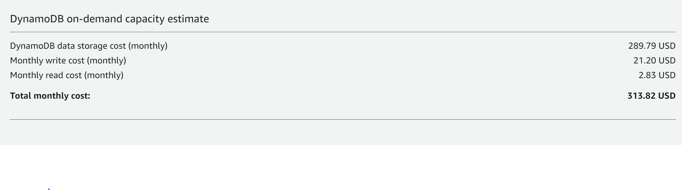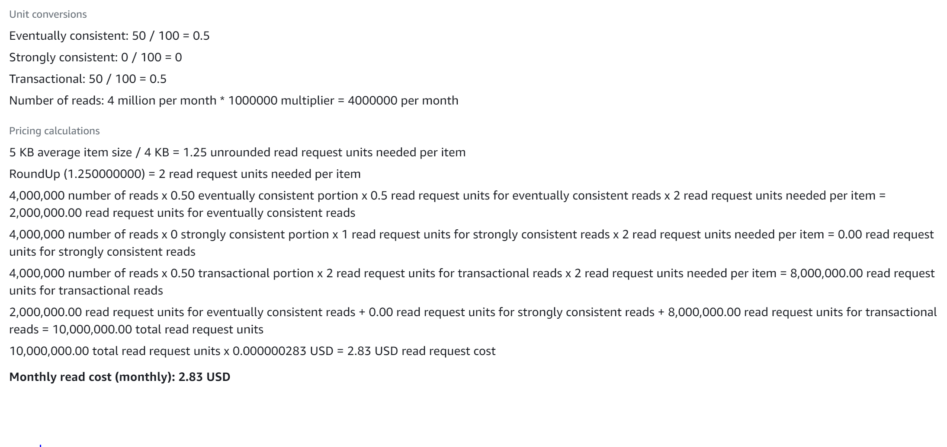

**4.EFS**

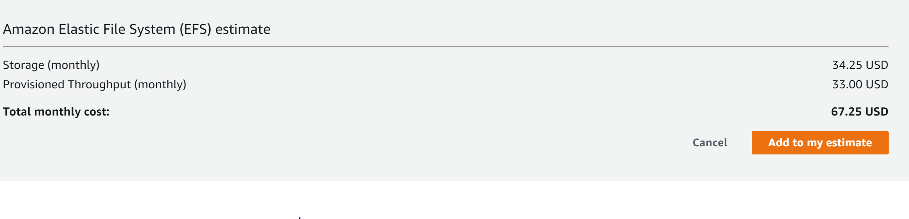**5.Enterprise support estimate**

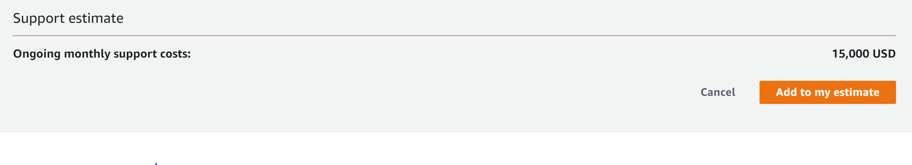

**Write a 150-word summary to explain your understandings and findings from this lab assignment.**

In this lab assignment, we have learnt about the AWS Pricing Calculator. Some of my understanding are as follows: -

1.AWS Pricing calculator helps us explore AWS services and create an estimate for the cost of your use cases on AWS. We can model the solutions before building them, explore the price points and calculations behind the estimate, and find the available instance types and contract terms that meets the company requirement. This enables us to make informed decisions about using AWS. We can plan the AWS costs and usage or price out setting up a new set of instances and services.

2. AWS Pricing Calculator is useful both for people who have never used AWS and for users who want to reorganize or expand their AWS usage. No prior experience with the cloud or AWS to use AWS Pricing Calculator is required.

3. AWS Pricing Calculator is free for use. It provides an estimate of your AWS fees and charges, but the estimate doesn't include any taxes that might apply to the fees and charges. AWS Pricing Calculator provides pricing details for our information only.

4. We can use AWS Pricing Calculator to generate monthly cost estimates for all Regions supported by your preferred service.